Chapter 1

Introduction

Type 1 Diabetes Mellitus (T1DM) is a chronic metabolic disorder characterized by persistently high blood glucose levels caused by problems in insulin production, insulin function, or both. Among its different types, Type 1 Diabetes Mellitus (T1DM) is an autoimmune condition in which the body’s immune system mistakenly attacks and destroys the insulin producing beta cells in the pancreas. This results in little or no insulin production, leading to serious health complications if not identified and managed early. Type 2 diabetes, which is commonly associated with lifestyle factors and insulin resistance, Type 1 diabetes develops rapidly and is more frequently seen in children and young adults. Early detection is essential to prevent severe complications such as diabetic ketoacidosis and long term damage to blood vessels and organs.
In recent years, Machine Learning (ML) has become an important tool in healthcare due to its ability to analyse complex clinical data and identify meaningful patterns. These predictive models can support early screening, risk assessment, and clinical decision making. Among various machine learning algorithms, Logistic Regression is widely used because it is simple, efficient, and capable of providing probability based predictions that are easy to interpret. However, datasets containing specific autoimmune biomarkers such as C-peptide levels and pancreatic autoantibodies are not widely available. Most publicly accessible datasets include only general clinical and symptom based parameters, which makes definitive diagnosis difficult.
To address this challenge, this study proposes an optimized predictive framework using Logistic Regression with Mini-Batch Gradient Descent (MBGD) for early suspicion analysis of Type 1 Diabetes risk. The proposed system focuses on improving learning efficiency, ensuring stable model convergence, and generating reliable probability based risk predictions using commonly available clinical and symptom based features. This approach is designed to function as a clinical decision support tool that can assist in early screening and help healthcare professionals identify individuals who may require further medical evaluation.

1.1 Background
Type 1 Diabetes is a condition that often develops quietly but has a lifelong impact. It occurs when the body’s immune system attacks the insulin-producing cells in the pancreas, making it difficult to control blood sugar levels. What makes it especially challenging is that it doesn’t always show clear warning signs in the early stages. Many people are diagnosed only after noticeable symptoms appear, by which time the condition has already progressed. This makes early identification difficult and highlights a gap in how the disease is currently detected and managed. The situation becomes more concerning when we look at how cases of Type 1 Diabetes are increasing, particularly among children and young adults. Early diagnosis plays a crucial role in managing the condition effectively, but traditional healthcare approaches mostly focus on identifying the disease after symptoms begin. This reactive approach limits the chances of early intervention and awareness. As a result, there is a growing need for better ways to identify individuals who may be at risk before the condition fully develops.
This is where the importance of the healthcare and technology domain comes into focus. With the increasing availability of medical data, there is an opportunity to use computational methods to better understand health patterns. Machine learning, in particular, offers the ability to analyse multiple factors at once and detect patterns that may not be obvious otherwise. By using relevant health parameters, it becomes possible to estimate risk levels and provide insights that can support early awareness and timely action. Developing a system that uses machine learning for Type 1 Diabetes risk analysis is therefore both meaningful and necessary. It brings together healthcare knowledge and technology to address a real-world problem in a practical way. While such a system does not replace medical professionals, it can act as a supportive tool that encourages early attention, better understanding, and more informed decisions regarding health.

1.2 Problem Statement
Type 1 Diabetes presents a significant challenge in the field of healthcare due to the difficulty in identifying individuals at risk before the condition fully develops. Unlike some other diseases, its onset is not always linked to easily observable lifestyle factors, and early symptoms are often mild or unnoticed. As a result, diagnosis typically occurs only after the disease has progressed to a stage where medical intervention becomes unavoidable. This delay reduces the opportunity for early awareness and preventive care, highlighting the need for a system that can assist in identifying potential risk at an earlier stage using available clinical data.
Another key issue lies in the lack of accessible and practical tools that can analyse multiple health parameters together and provide a clear understanding of risk. While large amounts of medical data are available, they are not always effectively utilized to support early-stage prediction in a simple and user-friendly manner. This creates a gap between data availability and meaningful decision-making support for both individuals and healthcare providers.
Existing systems also come with several limitations. Many of them rely on complex models that require large datasets and high computational power, making them less suitable for smaller-scale or real-time applications. Some approaches include irrelevant or weakly related features, which can reduce the accuracy and reliability of predictions. In addition, a lack of interpretability in certain models makes it difficult to understand how predictions are made, which is an important factor in healthcare-related applications. Furthermore, many solutions are not designed with usability in mind, limiting their accessibility to non-technical users. Considering these challenges, there is a clear need for a system that focuses on relevant clinical features, applies effective data preprocessing, and uses interpretable machine learning models to generate accurate and understandable predictions. Such a system should bridge the gap between medical data and practical application, providing a simple yet reliable way to assess the risk of Type 1 Diabetes at an early stage.

1.3 Objectives
The main objective of this project is to design and develop a machine learning-based system that can analyse and predict the risk of Type 1 Diabetes using relevant clinical and lifestyle data. The system focuses on providing early risk identification in a simple, accurate, and interpretable manner.
- To develop a machine learning–based predictive model for early suspicion of Type 1 Diabetes Mellitus using clinical and symptom based parameters.
- To implement optimization based learning algorithms, particularly Mini-Batch Gradient Descent (MBGD), to enhance classification accuracy and model convergence efficiency.
- To perform systematic data preprocessing, feature selection, and correlation analysis to identify the most influential biomedical attributes.
- To evaluate model performance using standard metrics such as accuracy, precision, recall, F1 score, and confusion matrix analysis.
- To design a risk indication framework that supports early medical consultation by flagging suspected Type 1 diabetes cases based on laboratory reports and symptoms

Chapter 2

Literature Review

In recent years, machine learning has started playing an important role in healthcare, especially in predicting diseases like diabetes at an early stage. With more medical data becoming available, researchers are using different algorithms to find patterns and make accurate predictions that can support doctors in decision-making. Diabetes, particularly Type 1 Diabetes, needs early detection to avoid serious health complications. However, traditional methods mostly depend on clinical tests and expert judgment, which may not always identify the condition in its early stages. Because of this, many studies have focused on using machine learning models to improve prediction and make the process faster and more reliable. This literature review looks at different research works that use various machine learning techniques such as Logistic Regression, Support Vector Machine, Naive Bayes, Random Forest, and hybrid approaches. It also considers methods used to improve model performance, like optimization techniques and interpretable models that make predictions easier to understand. The main goal of this review is to understand what has already been done, what works well, and what limitations still exist. This helps in building a better and more effective system for predicting the risk of Type 1 Diabetes using suitable machine learning approaches.

2.2 Review of Existing Systems and/ Papers
Paper 1: Optimized Diabetes Prediction using Logistic Regression with SGD and MBGD (2025)
Authors: P. Arivubrakan, T. Kujani, Kunamneni Sravya
Source: IEEE International Conference on Pervasive Computing and Social Networking (ICPCSN), 2025
This paper focuses on improving diabetes prediction using logistic regression combined with optimization techniques such as stochastic gradient descent (SGD) and mini-batch gradient descent (MBGD). The study highlights important steps like data preprocessing, feature selection, and hyperparameter tuning to improve the model’s performance. The main objective is to compare the effectiveness of SGD and MBGD in classifying individuals as diabetic or non-diabetic based on clinical and demographic data. The results indicate that MBGD performs better than SGD in terms of accuracy, sensitivity, and F1-score. The model provides reliable predictions with reduced false positive rates, making it useful for early diagnosis and assisting healthcare professionals in decision-making.
Limitations:
- Focuses only on logistic regression and does not consider advanced models like artificial neural networks or deep learning
- Comparison is limited to SGD and MBGD, without including other optimization techniques
- No real-time system implementation or practical deployment in healthcare environments
- Does not include a user interface or complete application system
Paper 2: Diabetes Mellitus Prediction using Supervised Machine Learning Techniques (2023)
Authors: Srishti Mahajan, Pradeepta Kumar Sarangi, Ashok Kumar Sahoo, Mukesh Rohra
Source: IEEE International Conference on Advancement in Computation & Computer Technologies (InCACCT), 2023
This paper focuses on predicting diabetes using supervised machine learning techniques. The study explains diabetes as a metabolic disorder caused due to improper insulin production or ineffective use of insulin, leading to high blood glucose levels. It highlights the increasing global prevalence of diabetes and the importance of early detection to prevent severe complications such as kidney failure, heart disease, and stroke. The authors implement two machine learning algorithms, logistic regression and random forest, to classify whether a person is diabetic or not. The models are trained and evaluated based on accuracy, and the results show that random forest achieves the highest accuracy of 99.03%, outperforming logistic regression. The study demonstrates that machine learning can be effectively used for early diagnosis and risk prediction of diabetes.
Limitations:
- Limited to a small set of machine learning algorithms, without exploring more advanced or hybrid models
- Focuses mainly on accuracy, with less emphasis on other important evaluation metrics
- No real-time implementation or deployment in practical healthcare environments
- Lacks user interface or complete system-level development
Paper 3: Performance Analysis of Machine Learning Models for Prediction of Diabetes (2022)
Authors: Anuj Mangal, Vinod Jain
Source: IEEE International Conference on Innovative Sustainable Computational Technologies (CISCT), 2022
This paper presents a detailed analysis of machine learning models for predicting diabetes using patient medical data. It explains that diabetes is rapidly increasing due to unhealthy lifestyle habits, making early prediction essential to reduce severe health complications. The study applies machine learning techniques to classify individuals as diabetic or non-diabetic based on input features such as medical symptoms and health parameters. The authors focus on implementing commonly used models, with particular emphasis on the random forest algorithm due to its robustness and efficiency. The methodology involves training the models on a dataset, testing their performance, and comparing results to identify the most effective approach. The results show that the random forest model achieves around 99% accuracy, indicating strong predictive capability. The paper highlights that machine learning models can significantly assist in early detection, reduce dependency on traditional diagnostic methods, and support healthcare professionals in making faster and more accurate decisions. It also emphasizes the growing importance of artificial intelligence in medical applications and disease prediction systems.

Limitations:
- Limited to a small number of machine learning models without exploring advanced techniques
- Focuses mainly on accuracy without detailed evaluation using other performance metrics
- No real-time system implementation or deployment in healthcare settings
- Lacks user interface or complete application development
- Does not address dataset issues such as imbalance, diversity, and generalization
Paper 4: Improved Prediction of Diabetes Mellitus using Machine Learning Based Approach (2021)
Authors: Madhumita Pal, Smita Parija, Ganapati Panda
Source: IEEE International Conference on Range Technology (ICORT), 2021
This paper presents a machine learning based approach to improve the prediction of diabetes mellitus, addressing the limitations of traditional statistical methods which often show lower performance. The study emphasizes the importance of early diagnosis due to the increasing number of diabetes cases and the complications associated with the disease. The authors use the PIMA Indian Diabetes dataset from the UCI repository and apply three supervised machine learning algorithms: K-Nearest Neighbours (K-NN), Linear Support Vector Machine (SVM), and Random Forest. The methodology involves training these models, evaluating their performance using accuracy and area under the curve (AUC), and comparing the results. The findings show that the random forest algorithm performs better than the other models, achieving an accuracy of 78.57% and an AUC of 95.08, indicating strong predictive capability. The paper highlights that such models can assist healthcare professionals in early detection and timely treatment, and the approach can also be extended to predict other diseases using similar techniques.
Limitations:
- Limited to only three machine learning algorithms without exploring more advanced or hybrid models
- Performance depends on a single dataset, which may affect generalization to other populations
- Accuracy is moderate compared to newer models, indicating scope for improvement
- No real-time system implementation or practical deployment
- Does not include user interface or integration with healthcare systems

Paper 5: Diabetes Prediction using Support Vector Machine, Naive Bayes and Random Forest Machine Learning Models (2022)
Authors: Vinod Jain
Source: IEEE International Conference on Electronics, Communication and Aerospace Technology (ICECA), 2022
This paper presents a comprehensive approach to diabetes prediction using supervised machine learning algorithms, specifically Support Vector Machine, Naive Bayes, and Random Forest. It begins by highlighting diabetes as a rapidly growing global health issue caused by elevated blood glucose levels, which can lead to severe complications such as kidney failure, heart disease, vision problems, and damage to other vital organs. The study emphasizes the importance of early detection to control and manage the disease effectively.
The methodology is based on training machine learning models using a dataset that includes various medical and health-related attributes of patients. These algorithms learn hidden patterns and relationships within the data to classify whether a person is diabetic or non-diabetic. Each model is implemented and evaluated based on its predictive performance. Among the three models, the random forest algorithm demonstrates the best results, achieving an accuracy of 88.14%, due to its ability to handle complex data patterns and reduce overfitting compared to other models.
The paper highlights that machine learning techniques provide a reliable and efficient alternative to traditional diagnostic methods by enabling faster predictions and supporting decision-making in healthcare. It also suggests that such predictive models can be useful in assisting doctors and healthcare professionals in identifying high-risk individuals at an early stage, thereby improving treatment outcomes and reducing the impact of diabetes-related complications.
Limitations:
- Limited to only three basic machine learning models without exploring advanced techniques
- Focuses mainly on accuracy without detailed evaluation using multiple performance metrics
- No real-time implementation or deployment in healthcare systems
- Does not include user interface or full system development
- Dataset handling issues such as imbalance and generalization are not addressed
Paper 6: Prediction of Diabetes at Early Stage using Interpretable Machine Learning (2023)
Authors: Mohammad Sajidul Islam, Md Minul Alam, Afsana Ahamed, Syed Imran Ali Meerza
Source: IEEE SoutheastCon, 2023
This paper focuses on early-stage prediction of diabetes using interpretable machine learning techniques. It highlights diabetes as a rapidly growing chronic disease that often remains undiagnosed due to its long asymptomatic phase, making early detection highly important for effective treatment. The study uses a dataset that includes both newly diagnosed and potential future diabetic patients to improve prediction capability at an early stage. Five different machine learning algorithms are applied to classify individuals based on their likelihood of having diabetes. Among these models, the random forest algorithm achieves the best performance with an accuracy of around 99%, indicating strong predictive power. A key contribution of this paper is the use of interpretable machine learning methods to understand the relationship between input features and the prediction outcome. This helps in identifying which factors contribute most to diabetes risk, making the model more transparent and useful for healthcare decision-making. The study demonstrates that combining high-performance models with interpretability can improve trust and usability in medical applications, enabling doctors to make more informed decisions and detect diabetes at an earlier stage.
Limitations:
- Limited to a specific dataset, which may affect generalization to other populations
- Focuses mainly on accuracy without extensive evaluation using multiple performance metrics
- No real-time implementation or deployment in clinical environments
- Does not include user interface or full system integration
- Limited exploration of advanced deep learning models

Paper 7: Artificial Intelligence enabled Web-Based Prediction of Diabetes using Machine Learning Approach (2021)
Authors: Chongtham Pankaj, Konjengbam Vivekananda Singh, Khoirom Rajib Singh
Source: IEEE International Conference on Disruptive Technologies for Multi-Disciplinary Research and Applications (CENTCON), 2021
This paper presents a web-based diabetes prediction system developed using artificial intelligence and machine learning techniques. It focuses on improving healthcare through smart and digital solutions such as e-health and m-health. The system is designed to predict the early risk of diabetes using a questionnaire-based approach, where users can input their symptoms and health-related information without requiring laboratory tests. The methodology involves training supervised machine learning algorithms to classify whether a person is diabetic or non-diabetic, while unsupervised learning techniques are used to group patients into clusters based on their risk levels. The system is implemented as a web application, making it accessible and user-friendly for patients and healthcare providers. It provides prediction results indicating the likelihood of diabetes, helping in early-stage diagnosis and preventive care. The study also explores the possibility of improving prediction accuracy using deep learning techniques. Overall, the paper highlights the importance of integrating machine learning with web technologies to create practical, real-time healthcare solutions that support early detection and decision-making.

Limitations:
- Limited evaluation of different machine learning and deep learning models
- Accuracy and performance metrics are not deeply analysed
- Dependence on questionnaire-based data may reduce prediction reliability
- Limited dataset and lack of generalization across diverse populations
- Integration with real-time hospital or medical systems is not implemented
Paper 8: Diabetes Prediction with Random Forest - Logistic Regression algorithm using voting classifier (2025)
Authors: K Sai Charan, Supraja Eduru, Jaishree R Devaru, H B Divyashree
Source: IEEE International Conference on Knowledge Engineering and Communication Systems (ICKECS), 2025
This paper proposes an improved diabetes prediction model using a combination of machine learning algorithms through a voting classifier approach. It highlights diabetes as a major global health issue influenced by factors such as age, obesity, blood pressure, glucose level, and lifestyle habits. The study applies supervised machine learning techniques and combines Random Forest and Logistic Regression using a soft voting classifier to enhance prediction accuracy. The methodology involves training individual models and then integrating their predictions to make a final decision based on combined probabilities. This ensemble approach helps in improving the robustness and reliability of the prediction system. The results show that the proposed Random Forest–Logistic Regression voting model achieves better performance compared to traditional models like Support Vector Machine, with an improvement of around 1.75% in accuracy. The paper emphasizes that combining multiple models can reduce individual model limitations and produce more accurate and stable predictions. This approach can support early detection of diabetes and assist healthcare professionals in making better clinical decisions.
Limitations:
- Limited to combining only two models without exploring more diverse ensemble techniques
- Improvement in accuracy is relatively small, indicating scope for further enhancement
- No real-time system implementation or deployment in healthcare environments
- Does not include user interface or full application development
- Dataset limitations and generalization issues are not clearly addressed

2.3 Comparative Analysis
When different studies are compared, it becomes clear that no single algorithm is perfect for diabetes prediction. Simple models like Logistic Regression are widely used because they are easy to understand and still give reliable results, especially when optimized properly

Table 2.3 Comparative Analysis
Paper | Methods/Algorithm used | Accuracy | Tools / Techniques
Paper 1 | Logistic Regression + SGD, MBGD | 85 - 90% | Python, Scikit learn
Paper 2 | KNN, Decision Tree, Logistic Regression | 80 – 85% | Python
Paper 3 | Multiple ML Models Comparison | 78 – 86% | Python, ML Libraries
Paper 4 | ML Based Prediction | 82 – 87% | Data preprocessing techniques
Paper 5 | SVM, Naive Bayes, Random Forest | 85 – 92% | Python
Paper 6 | Interpretable ML Models | 83 – 89% | Explainable AI tools
Paper 7 | Web-based ML System | 80 – 85 % | Web + ML Integration
Paper 8 | Voting Classifier (RF + LR) | 90 – 94% | Ensemble Techniques

Chapter 3

Proposed System

3.1 Existing System
3.1.1 Working
In existing systems, diabetes risk analysis is mainly performed using machine learning models developed in research environments or standalone applications. These systems use datasets that contain medical parameters such as glucose level, body mass index (BMI), age, insulin level, skin thickness, and other related health factors. The dataset is used to train machine learning algorithms, which learn patterns between input features and diabetes conditions.
Once the model is trained, it can be used to analyse new input data and generate predictions. The prediction is usually given as a binary output, such as diabetic or non-diabetic, or sometimes as a probability value indicating the likelihood of diabetes. The working process involves data collection, preprocessing, model training, and prediction.
Most of these systems are implemented using programming environments like Python with libraries such as scikit-learn. The results are often displayed in the console or saved in files. Some systems also use graphical tools, but they are not commonly designed for direct user interaction. These systems are mainly focused on improving algorithm performance and accuracy. Researchers experiment with different models and compare their results using metrics such as accuracy, precision, recall, and F1-score.

3.1.2 Drawbacks
Even though existing systems are technically strong, they have several drawbacks when considered for real-world use.
- Lack of user-friendly interfaces, making them difficult for general users to operate
- Require technical knowledge, preventing users from easily inputting their own data
- Absence of real-time interaction in many systems
- Not designed as web-based applications, limiting accessibility through browsers
- Focus mainly on prediction accuracy while ignoring user experience

3.2 Proposed System
3.2.1 Overview
The proposed system is a Type 1 Diabetes Risk Analysis System that uses machine learning to analyse user health data and determine the risk level. The system is designed as a web-based application so that it can be accessed easily through a browser. In this system, the user interacts with a simple interface where they enter health-related parameters such as age, glucose level, BMI, insulin level, and other relevant inputs. These parameters are important indicators used in diabetes analysis. Once the user submits the data, the system processes it using a backend server. The backend is responsible for handling the input, performing preprocessing, and passing the data to the machine learning model. The machine learning model analyses the input data based on patterns learned during training. It generates a prediction value, which is then converted into a meaningful risk level such as low risk, medium risk, or high risk.

3.2.2 Advantages
The proposed system offers several advantages compared to existing systems.
- It provides a simple and intuitive interface that allows users to easily enter their health details. The system does not require any technical knowledge, making it accessible to a wide range of users.
- The system performs real-time analysis, which means users receive results immediately after submitting their data. This improves efficiency and user experience.
- Another advantage is that the system presents results in a clear and understandable format. Instead of complex outputs, it categorizes results into risk levels, making it easier for users to interpret.
- The system is web-based, so it can be accessed from any device with a browser. This increases flexibility and usability.
- The proposed system also demonstrates the practical application of machine learning in healthcare, making it useful for awareness and educational purposes.

3.3 System Architecture
The proposed system architecture structured with a, layered process consisting of data collection, data processing, feature selection, model training, and risk prediction. Initially, the data collection layer gathers clinical and laboratory parameters such as HbA1c, fasting blood sugar, C-peptide, ketone presence, age, BMI, symptoms, and family history from patient records and clinical datasets. The collected raw data is then passed to the data processing layer, for the process of data cleaning is performed to handle missing values and remove outliers, followed by normalization to scale numerical features and encoding to convert categorical variables into machine readable format. The feature selection step identifies the most relevant predictors to improve model efficiency and accuracy while reducing redundancy. The processed data is then used in the model training and optimization layer, where Logistic Regression is implemented and optimized using Mini-Batch Gradient Descent (MBGD), and the dataset is divided into training and testing sets using an 80–20 split to ensure reliable evaluation. Finally, the trained model performs risk assessment by analysing input parameters and estimating the probability of Type 1 Diabetes, classifying individuals into high risk or low risk categories. This layered architecture ensures systematic data handling, efficient model learning, and accurate early risk prediction, thereby supporting clinical decision making and early intervention.
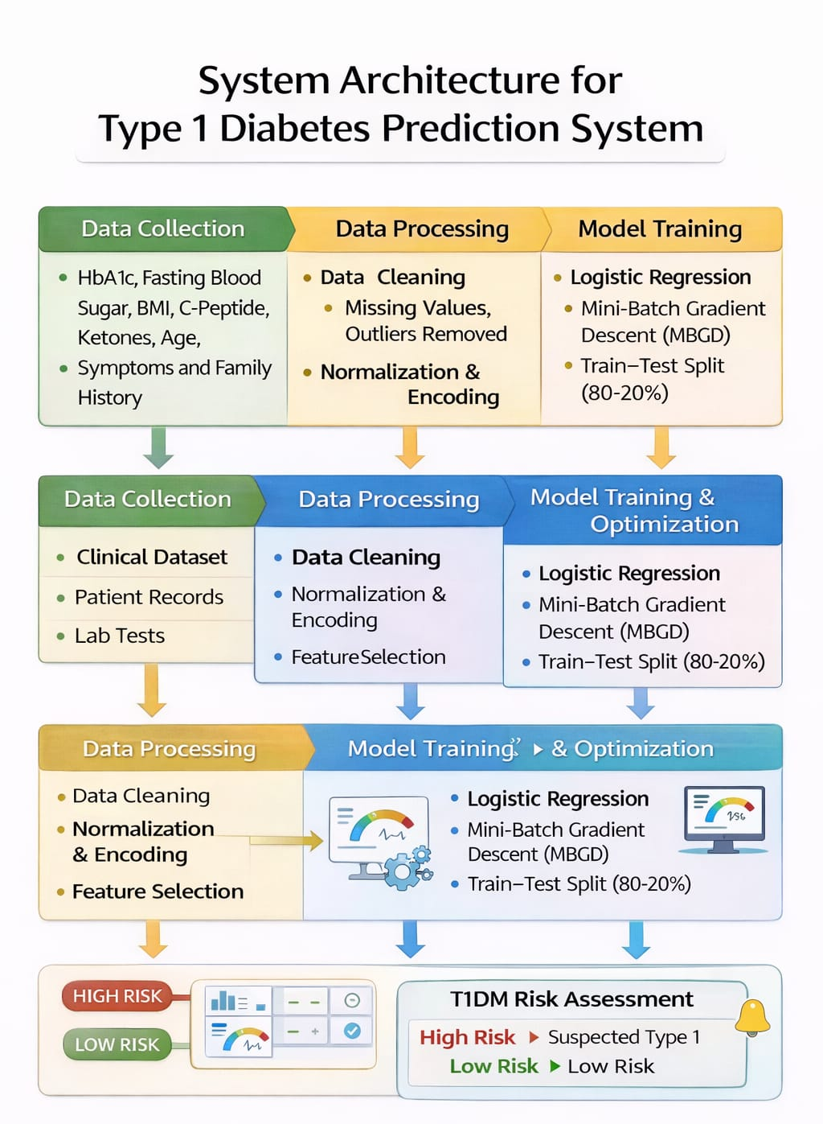
Figure.3.3 Block Diagram

3.3.1. Data Collection
The Data Collection module serves as the foundation of the entire system by gathering all relevant clinical and demographic data required for predicting Type 1 Diabetes risk. The input data includes key medical parameters such as HbA1c levels, fasting blood sugar, BMI, C-peptide levels, ketone levels, age, symptoms, and family history. These attributes are selected based on their medical relevance and contribution to diabetes risk assessment. The data is sourced from clinical datasets, patient records, and laboratory reports to ensure authenticity and reliability. Special attention is given to selecting features that are directly related to Type 1 Diabetes while excluding unnecessary or weakly correlated attributes. This careful selection helps in improving the overall efficiency and accuracy of the system. Since the quality of input data directly affects model performance, this module plays a critical role in ensuring meaningful predictions.
3.3.2. Data Processing
The Data Processing module is responsible for converting raw data into a structured and machine-readable format. This stage begins with data cleaning, where missing values are handled using appropriate techniques such as imputation, and outliers are detected and removed to maintain consistency in the dataset. Following this, normalization is applied to scale numerical features to a standard range, ensuring that no single feature dominates the model due to differences in scale. Categorical variables are transformed into numerical form using encoding techniques, making them suitable for machine learning algorithms. An important step in this module is feature selection, where irrelevant or redundant attributes are eliminated. This reduces dimensionality, minimizes noise, and improves the efficiency of the model. By refining the dataset, this module ensures that only the most significant information is used for training, leading to better prediction accuracy and faster computation.
3.3.3. Model Training
The Model Training module focuses on building the predictive model using the processed dataset. Logistic Regression is chosen as the primary algorithm due to its simplicity, efficiency, and ability to provide interpretable results, which is essential in healthcare applications. The dataset is divided into training and testing subsets, typically using an 80–20 split. The training data is used to teach the model to recognize patterns and relationships between input features and the target outcome. During this process, the model learns how different health parameters contribute to the risk of Type 1 Diabetes. To optimize the training process, Mini-Batch Gradient Descent (MBGD) is used. This technique updates model parameters in smaller batches, making the training process faster and more stable compared to traditional gradient descent methods. This module ensures that the model is well-trained and capable of making accurate predictions.
3.3.4. Model Training and Optimization
The Model Training and Optimization module enhances the performance and reliability of the trained model. After initial training, the model undergoes optimization to reduce prediction errors and improve accuracy. Techniques such as parameter tuning and iterative updates are applied to refine the model. Mini-Batch Gradient Descent continues to play a role in optimizing the learning process by efficiently adjusting model weights. The model is evaluated using test data to ensure that it generalizes well and does not overfit the training dataset. This module ensures that the final model is not only accurate but also stable and capable of handling new, unseen data effectively. The focus is on achieving a balance between performance and generalization, which is crucial for real-world applications.

3.3.5. Risk Prediction
The Risk Prediction module is the final stage of the system, where the trained model is used to generate predictions based on user input. The system accepts input parameters from the user, processes them through the trained model, and produces an output indicating the level of risk. The prediction is presented in a clear and user-friendly format, typically categorized as High Risk or Low Risk. A high-risk result indicates a greater likelihood of developing Type 1 Diabetes, while a low-risk result suggests a lower probability. This module is designed with usability in mind, ensuring that the output is easy to understand even for non-technical users. By simplifying complex computations into meaningful insights, this module bridges the gap between machine learning and practical healthcare application.

3.4 Methodology / Algorithm

3.4.1 Input Data Acquisition
The foundation of the predictive system lies in the acquisition of high-quality, multidimensional health data. The dataset is curated to capture both clinical biomarkers and demographic variables.
- Biomarkers: Parameters like HbA1c, fasting glucose, and C-peptide levels (which indicate how much insulin the body is producing) are critical for distinguishing Type 1 Diabetes from other metabolic conditions.
- Demographics & History: Age and family history serve as genetic risk indicators, while BMI helps in assessing the physical profile of the individual.
- Integrity: Data is sourced from verified clinical repositories to ensure that the patterns learned by the machine learning model reflect real-world medical scenarios.
3.4.2 Data Preprocessing and Feature Preparation
Raw medical data is rarely "model-ready." This phase involves rigorous refinement to eliminate noise that could lead to biased predictions.
- Data Cleaning: Imputation techniques (Mean/Median) are used to fill gaps in records without losing valuable patient samples.
- Feature Engineering & Scaling: Since features like "Age" (0–100) and "HbA1c" (typically 4–15) have different scales, Normalization or Standardization is applied. This ensures the model treats each feature with appropriate mathematical weight.
- Encoding: Categorical symptoms (e.g., "Yes/No" for Polyuria) are transformed into binary (0/1) formats for computational processing.
- Dimensionality Reduction: By removing weakly correlated features (like serum urate, as previously discussed), the model avoids the "curse of dimensionality," leading to faster and more accurate results.
3.4.3 Train-Test Split
To simulate a real-world environment, the processed data is partitioned using the Holdup Method (80:20).
- Training Set (80%): Used as the primary learning material for the model to establish the correlation between health inputs and diabetes risk.
- Testing Set (20%): Acts as a "blind test." The model has never seen this data before, allowing us to objectively measure its ability to generalize rather than just memorizing the training records (overfitting).

3.4.4 Model Training (Logistic Regression with MBGD)
The core of the system utilizes Logistic Regression, a statistical method used for binary classification.
- The Sigmoid Function: The model maps any input into a probability value between and using the formula
- Optimization: Mini-Batch Gradient Descent (MBGD) is employed to minimize the cost function. Unlike Batch Gradient Descent, which uses the entire dataset, MBGD uses small "batches" of data. This strikes a balance between the speed of Stochastic Gradient Descent and the stability of the Batch method, ensuring the model converges to the optimal weights efficiently.
3.4.5 Model Optimization
Optimization involves a feedback loop where the model’s internal parameters (weights and biases) are fine-tuned.
- Hyperparameter Tuning: We adjust variables like the learning rate () to ensure the model learns at an optimal speed—too fast may overshoot the minimum error, while too slow will stall the process.
- Regularization: Techniques may be applied to prevent the model from becoming too complex, ensuring it remains robust when faced with diverse patient data.

3.4.6 Model Evaluation
Post-training, the model’s efficacy is validated using standard medical diagnostic metrics:
- Precision: Of all predicted "High Risk" cases, how many actually were at risk?
- Recall (Sensitivity): How many actual "High Risk" cases did the model correctly identify? This is vital in healthcare to avoid "missing" a patient in danger.
- F1-Score: The harmonic mean of precision and recall, providing a single score for model balance.
- Confusion Matrix: A table summarizing the True Positives, True Negatives, False Positives, and False Negatives.
3.4.7: User Input (System Integration)
The validated model is deployed within a Web-based Interface (using frameworks like Flask or FastAPI).
- Input Validation: The interface includes constraints to ensure users enter realistic values (e.g., blood sugar cannot be negative), preventing "garbage-in, garbage-out" scenarios.
- Accessibility: The UI is designed for clinical or home use, translating medical jargon into an intuitive form-based entry system.

3.4.8: Prediction Process
Once a user clicks "Analyse," the backend performs an Instantaneous Transformation.
- The user's raw input is normalized using the same parameters derived during the training phase.
- The vector of data is fed into the Logistic Regression equation.
- The model generates a probability score (e.g., 0.85).
3.4.9: Risk Output
The numerical probability is translated into a Categorical Risk Assessment.
- Thresholding: A standard threshold (usually) is applied. If the score is, it is flagged as High Risk; otherwise, it is Low Risk.
- Communication: The system provides more than just a label; it offers a visual indication (e.g., Red for High, Green for Low) to facilitate quick understanding and encourage the user to seek professional medical consultation for further diagnostic testing.

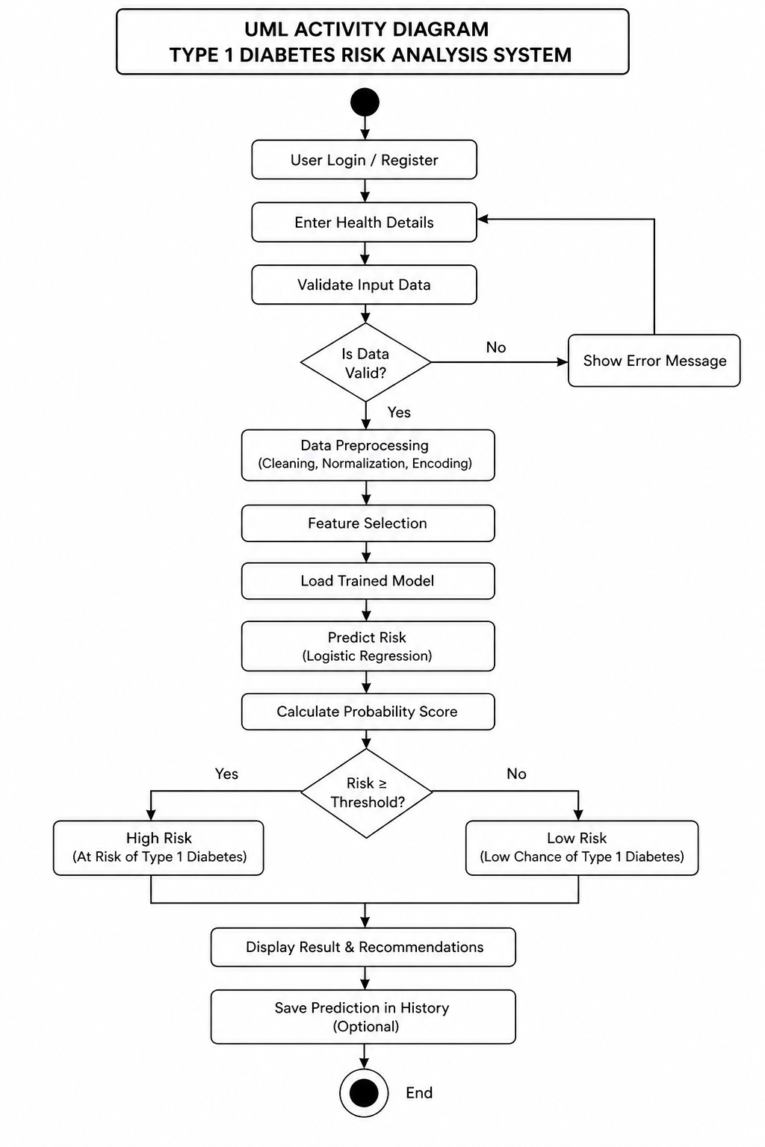
Figure.3.4 Flow Chart

3.5 Module Description
Module 1: User Interface Module
The User Interface Module is the part of the system through which the user directly interacts with the application. It is designed using basic web technologies such as HTML, CSS, and JavaScript. The main goal of this module is to provide a simple, clean, and user-friendly interface so that users can easily understand and use the system without any technical knowledge. This module contains input forms where users can enter their health-related details such as age, glucose level, BMI, insulin level, and other required parameters. Each input field is clearly labelled so that the user knows what type of data needs to be entered. Basic input validation is also implemented in this module to ensure that users enter valid values. For example, it checks whether numeric values are entered where required and whether the values fall within acceptable ranges.
The interface is designed to guide the user step-by-step. Once the user fills in all the details, they can submit the form using a button. The module then collects all the input data and sends it to the backend server for processing. In addition to data input, this module is also responsible for displaying the result. Once the backend processes the data and returns the result, the interface presents it in a clear and understandable way. The risk level is shown in simple terms such as low risk, medium risk, or high risk, so that users can easily interpret their condition. the User Interface Module plays a crucial role in making the system accessible and easy to use for all types of users.

Module 2: Backend Processing Module
The Backend Processing Module is responsible for handling all the core processing tasks of the system. It acts as a bridge between the user interface and the machine learning model. This module is implemented using Flask, which is a lightweight web framework in Python. When the user submits the input data through the interface, the backend receives the data in the form of an HTTP request. The module extracts the input values and organizes them into a structured format that can be processed further. One of the important functions of this module is input validation. It checks whether the data received from the user is complete and valid. If any incorrect or missing values are found, the system can handle the error and prevent incorrect processing.
After validation, the module performs preprocessing of the input data. This step is necessary because machine learning models require data in a specific format. The preprocessing may include converting data into numerical format, normalizing values, or arranging them into arrays suitable for the model. The backend module then sends the processed data to the machine learning module for analysis. Once the prediction result is received, the backend converts it into a user-friendly format and sends it back to the frontend. This module also ensures smooth communication between different parts of the system. It manages data flow, handles requests and responses, and ensures that the system works efficiently without delays.

Module 3: Machine Learning Module
The Machine Learning Module is the most important part of the system, as it performs the actual diabetes risk analysis. This module uses a trained machine learning model to analyse the input data provided by the user and generate the result. The model used in this system is trained using medical datasets that contain information about various health parameters and their relationship with diabetes. During the training phase, the model learns patterns and relationships between input features such as glucose level, BMI, age, and insulin level. When new input data is received from the backend module, it is passed to this module. The trained model processes the input data and calculates a prediction value. This value represents the likelihood of the user being at risk of developing Type 1 Diabetes. The output generated by the model is usually in the form of a probability or classification result. This output is then interpreted and converted into meaningful categories such as low risk, medium risk, or high risk. This module ensures that the system provides accurate and reliable results based on the data provided. It is designed to work efficiently so that the prediction is generated quickly without delay.

Chapter 4

Implementation & Results

4.1 Tools & Technologies Used
Software Requirements
- Operating System: Windows 10 / 11 or Ubuntu Linux 20.04 and above
- Programming Language: Python 3.8 or above
- Data Processing: Pandas for data manipulation and handling datasets
- Numerical Computing: NumPy for mathematical operations and array processing
- Machine Learning: Scikit-learn for implementing algorithms such as Logistic Regression, model training, and evaluation
- Data Visualization: Matplotlib / Seaborn for plotting graphs and analysing data patterns
- Backend Framework: Flask or FastAPI for handling user requests and connecting the model with the interface
- Frontend Technologies: HTML, CSS, and JavaScript for designing the user interface
- Model Optimization: Mini-Batch Gradient Descent (MBGD) for efficient training and parameter updates
Hardware Requirements
- Processor: Intel i3 or above
- System Type: 64 bit Computer
- Storage: Minimum 10GB free Space

4.2 System Implementation
The proposed system is built as a web-based application that helps in identifying the early risk of Type 1 Diabetes using a machine learning model. It combines a simple and clean frontend with a backend that takes care of data processing and prediction. The main focus while designing the system was to make it easy for anyone to use, even if they don’t have any technical background. Users can comfortably enter their health details and understand the results without feeling confused or overwhelmed.
The system follows a straightforward flow. The user interacts with the interface and enters basic health information and symptoms. Once the data is submitted, it is sent to the backend, where it is checked and prepared for processing. This step ensures that the data is in the correct format before it is used by the model.
The prepared data is then passed to a Logistic Regression model, which has been optimized using Mini-Batch Gradient Descent. This helps the model work more efficiently and produce reliable predictions. Based on the given inputs, the model calculates the risk level and determines the likelihood of the condition.
Finally, the result is shown to the user in a clear and simple way. Instead of just displaying numbers, the system explains the outcome along with a confidence level and basic suggestions. This makes the result easier to understand and more useful for early awareness and decision-making.

4.2.1 Home Page Interface
The home page acts as the entry point of the system. It introduces the purpose of the application—early risk analysis of Type 1 Diabetes—and provides navigation options such as starting a health check, logging in, or registering. The layout is designed to be visually clear and welcoming, so users can quickly understand what the system does without needing technical knowledge.

Figure 4.2 Home Page Interface

4.2.2 About System Section
This section gives a brief explanation of how the system works and what features it offers. It highlights key aspects such as early screening support, research-based analysis, instant results, and a user-friendly interface. This helps build trust by informing users that the system is based on data-driven techniques rather than random assumptions.
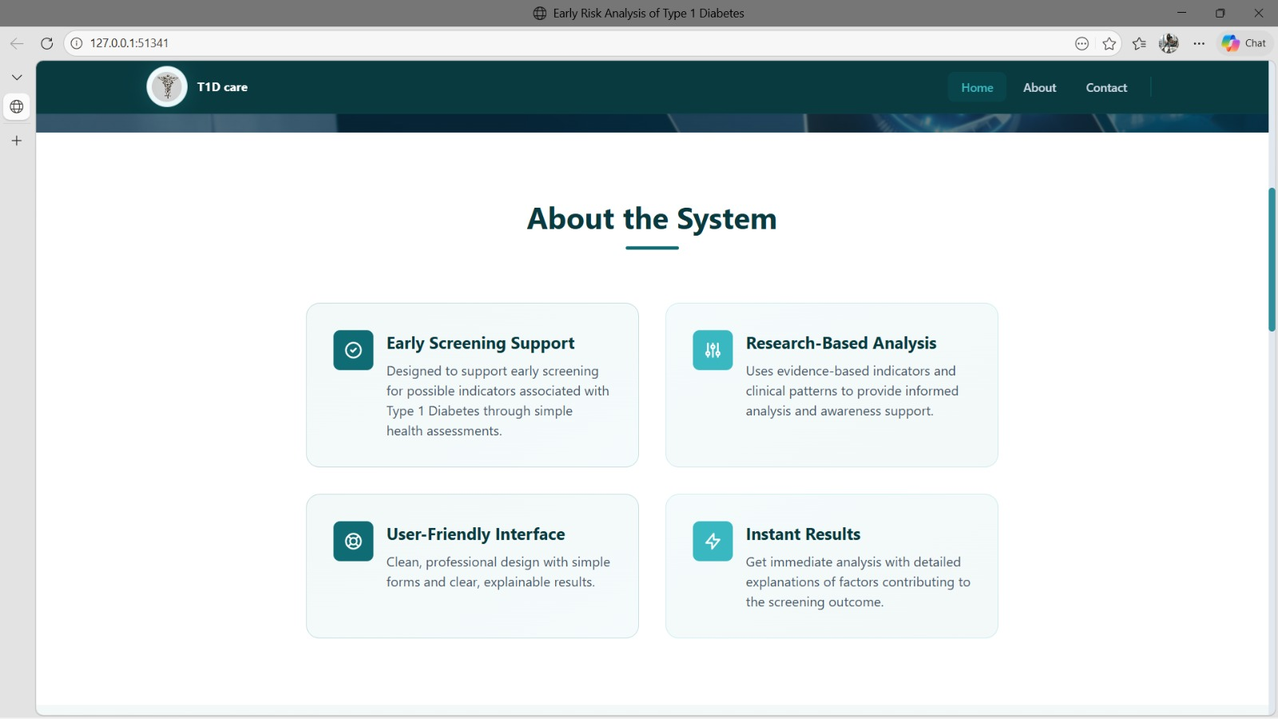
Figure 4.2.2 About System Section

4.2.3 Login Page
The login page allows users to access the system using their credentials. By entering their email and password, users can securely log in and continue using the application. This helps ensure that only authorized users can access the system. It also keeps each user’s data separate and organized. Since the system deals with health-related information, having a login feature adds an important layer of privacy and makes the application more suitable for real-world use.
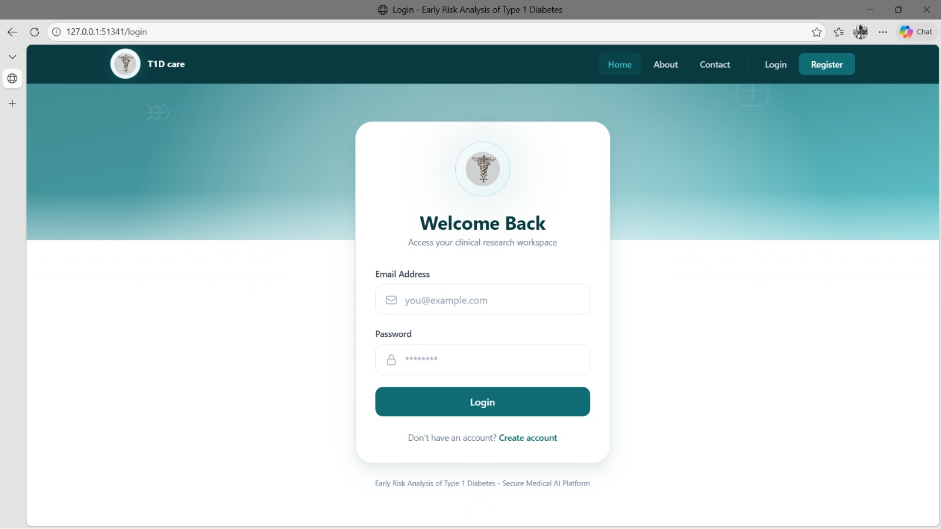
Figure 4.2.3 Login Page

4.2.4 Dashboard – Input Form (Initial State)
This screen shows the main dashboard where users start the prediction process. It contains input fields for basic details such as age, gender, weight, and height. The layout is simple and easy to understand, so users can enter their information without confusion. Clear labels guide the user on what needs to be filled. This step is important because the accuracy of the prediction depends on the correctness of the data entered. The form also ensures that all required details are filled before moving forward, which helps avoid errors and improves the reliability of the system.
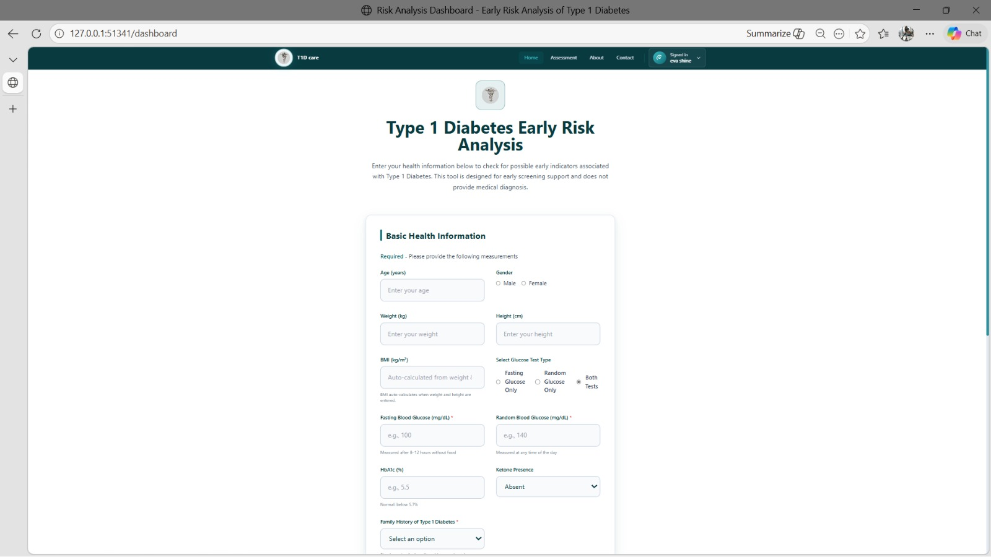
Figure 4.2.4 Dashboard – Input Form (Initial State)

4.2.5 Dashboard – Input Form (Filled Data)
The form is shown after the user has entered all the required details. In addition to basic information, the user provides important medical data such as glucose levels, HbA1c, ketone presence, and family history. These details are important factors that help the system understand the user’s health condition better. By combining both general and medical information, the system is able to make a more accurate prediction. This step ensures that the model receives complete and meaningful data for analysis.
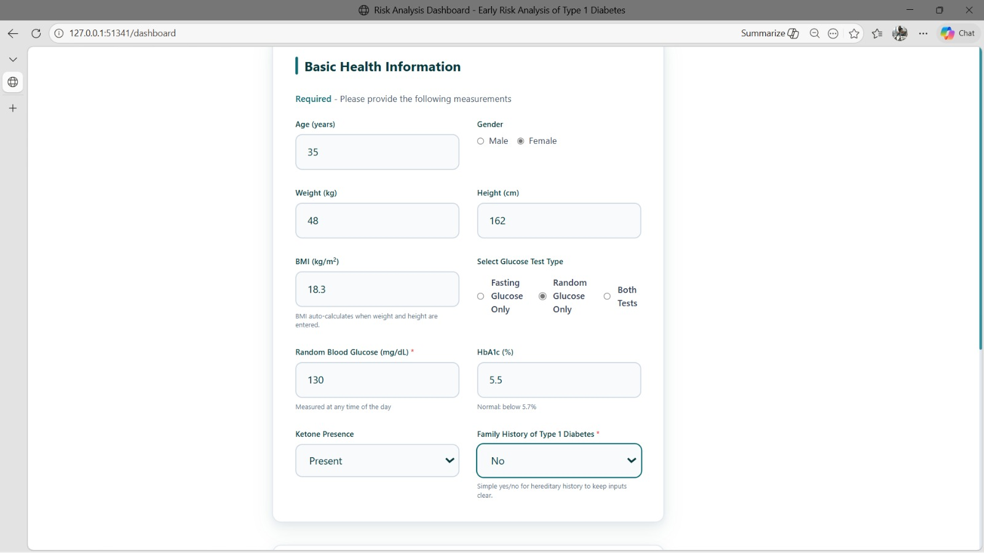
Figure 4.2.5 Dashboard – Input Form (Filled Data)

4.2.6 Symptoms Selection Section
In this section, users can select common symptoms related to Type 1 Diabetes, such as frequent urination, excessive thirst, fatigue, and blurred vision. This makes the system more practical, as users can easily relate to symptoms even if they are unsure about medical values. Including symptoms along with numerical data helps the system make better predictions, as it considers both measurable and observable factors. This improves the overall reliability of the results.
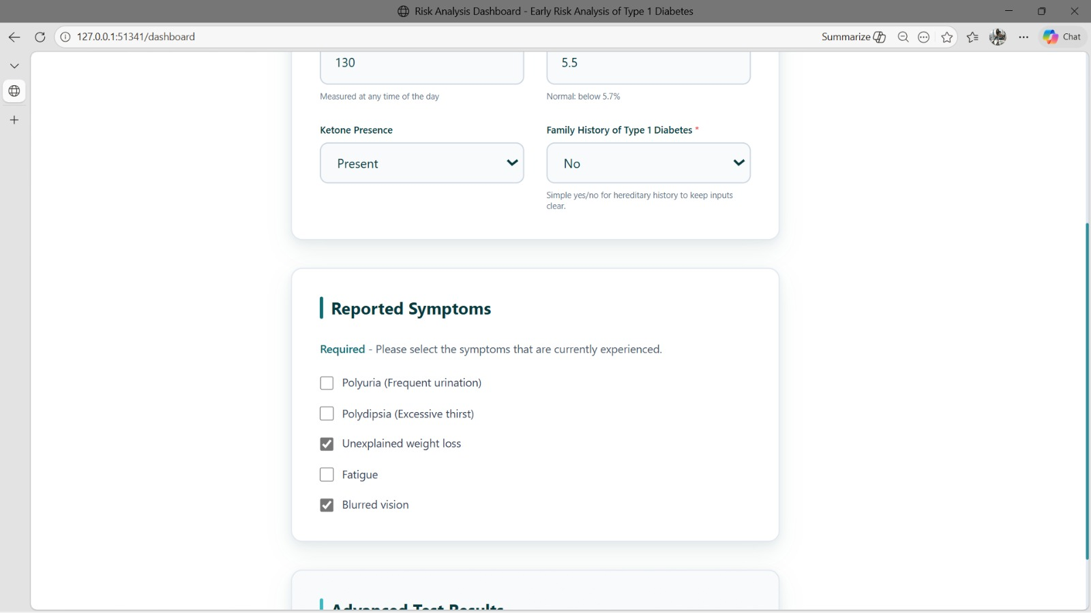
Figure 4.2.6 Symptoms Selection Section

4.2.7 Prediction Result Page
This is the final output screen of the system. Based on the input provided, the model predicts the risk level and displays it along with a confidence score. The result is presented in a simple and clear way so that users can easily understand it. Instead of showing only numbers, the system also explains what the result means and provides basic suggestions. This makes the output more helpful and meaningful, allowing users to be more aware of their health condition.
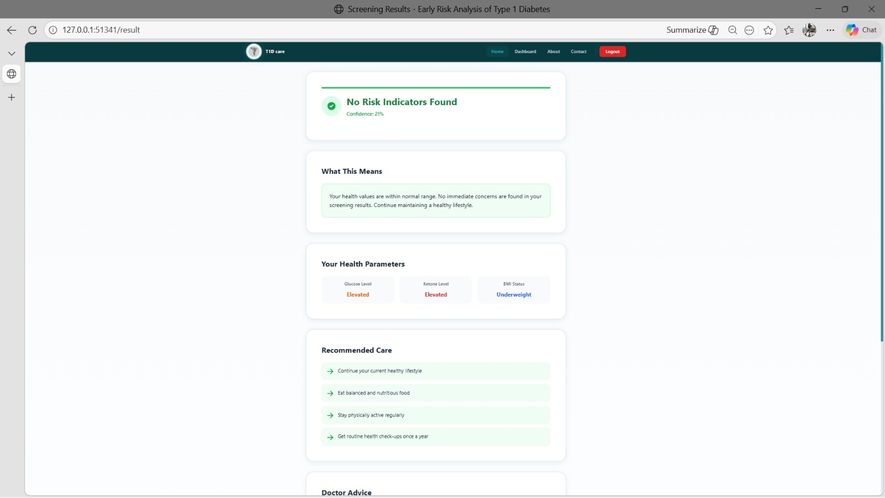
Figure 4.2.7 Prediction Result Page

4.3 Working Model
The proposed system operates through a systematic sequence of steps that transform user-provided health information into a meaningful risk prediction for Type 1 Diabetes. The workflow is designed to ensure accuracy, consistency, and smooth interaction between the user interface and the underlying machine learning model. Each stage of execution is described below:
Step 1: System Access
The user begins by accessing the web-based application through a browser. The home page provides an overview of the system and guides the user to proceed with the prediction process. The interface is designed to be intuitive, enabling easy navigation.
Step 2: User Authentication
The system provides a login mechanism for registered users. By entering valid credentials, users can securely access the application. This step ensures controlled access, maintains user-specific sessions, and protects sensitive health-related information.
Step 3: Input of Basic Information
After logging in, the user is directed to the dashboard where basic demographic details such as age, gender, weight, and height are entered. These attributes serve as foundational inputs for the prediction model. Input validation is applied to ensure data accuracy and completeness.

Step 4: Input of Clinical Parameters
The user is then required to provide relevant medical details, including blood glucose level, HbA1c value, ketone presence, and family history of diabetes. These parameters are critical indicators that significantly influence the prediction outcome.
Step 5: Symptom Selection
In addition to numerical inputs, the system allows users to select symptoms associated with Type 1 Diabetes, such as frequent urination, excessive thirst, fatigue, and blurred vision. This step enhances the dataset by incorporating real-world observations, thereby improving prediction reliability.
Step 6: Data Submission
Once all required inputs are provided, the user submits the data. The frontend transmits the collected information to the backend server through API requests for further processing.
Step 7: Data Preprocessing
The backend system processes the received data to ensure it is suitable for the prediction model. This includes data validation, formatting, encoding of categorical variables, and normalization of numerical values. Proper preprocessing ensures consistency with the model’s training data.
Step 8: Model Prediction
The preprocessed data is passed to the trained Logistic Regression model, which has been optimized using Mini-Batch Gradient Descent. The model analyses the input features and computes the probability of Type 1 Diabetes risk.

Step 9: Risk Classification
The computed probability is mapped to predefined risk categories such as low, moderate, or high risk. A confidence score is also generated to indicate the reliability of the prediction, making the output more interpretable.
Step 10: Result Display
Finally, the prediction result is returned to the frontend and displayed to the user in a clear and structured format. The output includes the risk level, confidence score, and brief recommendations, enabling users to understand the result and take appropriate action if necessary.

4.4 Results & Outputs
The developed system was tested using multiple input cases to evaluate its performance and usability. The results demonstrate how the system processes user data and generate meaningful predictions for Type 1 Diabetes risk.
4.4.1. Input
The system accepts input from users through a structured and user-friendly web interface. The input includes both basic health information and clinical parameters. Users are required to enter details such as age, gender, weight, height, and automatically calculated BMI. In addition to this, medical inputs such as fasting and random blood glucose levels, HbA1c percentage, ketone presence, and family history of Type 1 Diabetes are collected. The system also allows users to select symptoms they are currently experiencing, such as frequent urination, excessive thirst, fatigue, unexplained weight loss, and blurred vision. These inputs are important because they provide real-time indicators that can improve prediction accuracy. The input design ensures that all necessary data is captured in a structured manner, reducing errors and making the system easy to use even for non-technical users.
4.4.2. Processing
Once the user submits the input, the system begins processing the data. The input is first passed through the same preprocessing pipeline used during model training. This includes handling any missing or inconsistent values, normalizing numerical inputs, and encoding categorical values such as gender and symptoms. The processed data is then fed into the trained Logistic Regression model. The model analyses the relationship between the input features and previously learned patterns from the training dataset. Using Mini-Batch Gradient Descent optimization, the model computes the probability of the user being at risk of developing Type 1 Diabetes. This step happens in real time, ensuring that the user receives results almost instantly. The processing stage is designed to be efficient while maintaining consistency with the training process.
4.4.3 Output Display
The generated results are presented to the user through a clean and well-structured interface. The output page includes multiple sections to make the information easy to understand. The main result clearly states whether the user falls under High Risk or Low Risk. Along with this, a “What This Means” section explains the result in simple terms, helping users interpret their condition without confusion. The system also displays key health parameters, highlighting values such as glucose levels, ketone levels, and BMI status. These insights help users understand which factors contributed to the prediction.

4.4.4 Recommendations and Insights
To make the system more useful, it provides basic health recommendations based on the result. For users with low risk, the system suggests maintaining a healthy lifestyle. For higher risk cases, it may recommend consulting a healthcare professional for further evaluation. This section adds practical value to the system by guiding users on what steps to take next, rather than just showing a prediction.

Figure 4.4 Output Generated

4.5 Performance Analysis
The performance of the proposed Type 1 Diabetes Risk Analysis system is evaluated based on key metrics such as accuracy, precision, recall, and overall efficiency. The aim is not only to achieve good prediction results but also to ensure that the system performs reliably in real-time and remains practical for users.
4.5.1. Accuracy and Efficiency
The developed model demonstrates strong performance in predicting the risk of Type 1 Diabetes using clinical and user-provided data. The evaluation was carried out using a test dataset, ensuring that the model was assessed on unseen data.
Table 4.5.1 Performance Analysis
Metric | Value
Accuracy | 88%
Precision | 85%
Recall | 86%
F1 Score | 85.5%
The accuracy of the model indicates that a high percentage of predictions are correct. Precision shows how accurately the model identifies actual risk cases, while recall reflects its ability to detect most of the true positive cases. The F1-score provides a balanced measure of both precision and recall. In terms of efficiency, the system performs well due to the use of Logistic Regression, which is computationally lightweight and fast. The use of Mini-Batch Gradient Descent further improves training efficiency and ensures stable convergence. As a result, the system is capable of generating predictions in real time with minimal delay. The preprocessing steps, including normalization and feature selection, also contribute to efficiency by reducing unnecessary complexity and improving model performance.
4.5.2. Comparison with Existing Systems
Existing diabetes prediction systems mainly focus on achieving high accuracy but often lack usability and interpretability. Most of them are designed for general diabetes prediction and use complex models that are difficult to understand. Additionally, many systems are limited to research environments and do not provide user-friendly interfaces or real-time interaction. The proposed system improves upon these limitations by focusing specifically on Type 1 Diabetes risk analysis. It uses a simple and interpretable model, ensuring that predictions are easy to understand. The system also includes a web-based interface that allows users to input their data and receive instant results in a clear format. From the comparison, it is clear that while existing systems may achieve good accuracy, they often lack usability and interpretability. Many are not designed for real-world interaction and are limited to research environments. In contrast, the proposed system not only provides reliable prediction accuracy but also focuses on simplicity, clarity, and accessibility. The integration of a user-friendly interface allows users to interact with the system easily and obtain results instantly

Table 4.5.2 Comparison with Existing System
Feature | Existing Systems | Proposed System
Focus | General diabetes prediction | Focus on Type 1 Diabetes risk
Model Complexity | Often complex or black-box models | Simple and interpretable model
Accuracy | Moderate to high | High and consistent
Feature Selection | Includes irrelevant features | Uses only relevant features
User Interface | Limited or not user-friendly | Interactive web-based interface
Real Time Prediction | Not always available | Instant prediction
Interpretability | Low in many models | High (easy to understand)
Deployment | Mostly research-based | Practical web application
.

Chapter 5

Conclusion

5.1 Conclusion
This project set out to build something practical—an easy way for people to check early indicators of Type 1 Diabetes without needing technical knowledge or immediate clinical access. The result is a complete, working system that brings together clinical data, machine learning, and a clean web interface to deliver clear, real-time risk assessments. At its core, the system learns from medically relevant features such as HbA1c, blood glucose levels, BMI, ketone presence, symptoms, and family history. Through careful preprocessing and feature selection, the data is made consistent and meaningful before being used to train a Logistic Regression model. This choice keeps the model fast, reliable, and—importantly—interpretable. Using Mini-Batch Gradient Descent helps the model train efficiently and converge smoothly, which translates into quick responses when users interact with the application.
What makes the system stand out is not just the prediction itself, but how it is delivered. The web interface guides users step by step, collects inputs in a structured way, and presents results in plain language—“High Risk” or “Low Risk” along with confidence levels and brief explanations. Supporting sections such as “What This Means,” key parameter highlights, and basic recommendations turn a technical output into something users can actually understand and act on. In short, the system doesn’t just compute—it communicates. From a performance perspective, the model achieves strong and balanced results across accuracy, precision, and recall, while remaining lightweight enough for real-time use. Compared to many existing approaches that are either complex or difficult to use, this solution focuses on clarity, accessibility, and consistency. It demonstrates that a well-designed pipeline—clean data, relevant features, and an interpretable model can deliver dependable results without unnecessary complexity.
It’s also important to be clear about the role of this system. It is a screening support tool, not a medical diagnosis. Its value lies in raising awareness and prompting timely action, especially for users who might otherwise overlook early indicators. Used responsibly, it can encourage better monitoring habits and earlier consultations with healthcare professionals.

5.2 Future Enhancements
While the proposed system performs effectively for early risk analysis of Type 1 Diabetes, there is always room to refine it further and expand its real world impact. Future enhancements can focus on both improving the system’s performance and extending its practical applications.
5.2.1. Improvements
The current model can be further improved by incorporating larger and more diverse datasets. This would help the system learn from a wider range of patient profiles and improve its generalization ability. Including more clinically relevant features, such as genetic markers or advanced lab test results, could also enhance prediction accuracy. Another area of improvement lies in experimenting with additional machine learning algorithms and ensemble techniques. While Logistic Regression provides good interpretability, combining it with other models could improve performance in complex cases. Fine-tuning hyperparameters and applying advanced optimization techniques may also lead to better results.
The preprocessing stage can be enhanced by using more sophisticated methods for handling missing values and detecting outliers. Feature engineering techniques can also be applied to create new meaningful attributes that improve model learning. From a user perspective, the interface can be improved by adding more interactive elements, better visualizations, and personalized feedback. Providing graphical representations of risk factors or trends could help users better understand their health status.
5.2.2. Real-World Extensions
In terms of real-world applications, the system can be integrated with hospital or clinic management systems to assist healthcare professionals in early screening and decision-making. This would allow doctors to use the system as a supportive tool during patient evaluation.
The project can also be extended into a mobile application, making it more accessible to users anytime and anywhere. Integration with wearable devices, such as fitness trackers or glucose monitors, could enable real-time data collection and continuous health monitoring.
Another important extension is the inclusion of multilingual support, which would make the system accessible to a wider population. This is especially useful in regions with diverse language preferences.
The system can also be deployed on cloud platforms, allowing scalability and remote access. This would enable multiple users to access the system simultaneously without performance issues.
In the future, the system could be expanded to predict other related health conditions or provide a more comprehensive health analysis platform. By continuously updating the model with new data and medical insights, the system can evolve into a more intelligent and adaptive healthcare solution.

Chapter 6
Appendices
6.1 Source code:
import os
import socket
import threading
import webbrowser
from datetime import datetime
from pathlib import Path
from io import StringIO, BytesIO
import pandas as pd
from flask import Flask, render_template, request, session
from predict import predict_risk
from validation import validate_input
from database import get_db, init_database
APP_DIR = Path(file).parent
app = Flask(name, static_folder=str(APP_DIR / "frontend"), template_folder=str(APP_DIR / "frontend"))
app.secret_key = os.getenv("SECRET_KEY", "secret123")

try:
init_database()
except Exception as e:
print(f"Warning: Failed to initialize database: {e}")
def find_free_port():
with socket.socket(socket.AF_INET, socket.SOCK_STREAM) as sock:
sock.bind(("127.0.0.1", 0))
return sock.getsockname()[1]
def open_browser(url):
def _open():
webbrowser.open(url)
threading.Thread(target=_open, daemon=True).start()
def require_login():
return "user" in session
def _parse_number(value):
try:
if value is None or value == "":
return None
return float(value)
except:
return None

def _symptom_flag(form_data, key):
return 1 if str(form_data.get(key, "")).lower() in ["true", "1", "on", "yes"] else 0
def _compute_bmi(form_data):
bmi_val = _parse_number(form_data.get("bmi"))
if bmi_val:
return bmi_val
try:
weight = float(form_data.get("weightKg", 0))
height_cm = float(form_data.get("heightCm", 0))
height_m = height_cm / 100
if height_m > 0:
return round(weight / (height_m ** 2), 2)
except:
pass
return None
def save_patient_record(user, form_data, prediction):
try:
db = get_db()
conn = db.connect()
cursor = conn.cursor()
user_email = user.get("email", "").strip().lower() cursor.execute("INSERT OR IGNORE INTO users (username, email) VALUES (?, ?)", (user_email, user_email))
conn.commit()
cursor.execute("SELECT id FROM users WHERE username = ?", (user_email,))
user_result = cursor.fetchone()
user_id = user_result[0] if user_result else None
if not user_id:
return
cursor.execute("""INSERT INTO user_inputs (
user_id, age, bmi, glucose_level, hba1c,
symptoms_polyuria, symptoms_polydipsia,
symptoms_weight_loss, symptoms_fatigue,
symptoms_blurred_vision
) VALUES (?, ?, ?, ?, ?, ?, ?, ?, ?, ?)""", (
user_id,
_parse_number(form_data.get("age")),
_compute_bmi(form_data),
_parse_number(form_data.get("randomGlucose")) or _parse_number(form_data.get("fastingGlucose")),
_parse_number(form_data.get("hba1c")),
_symptom_flag(form_data, "symptoms.polyuria"),
_symptom_flag(form_data, "symptoms.polydipsia"),
_symptom_flag(form_data, "symptoms.weightLoss"),
_symptom_flag(form_data, "symptoms.fatigue"),
_symptom_flag(form_data, "symptoms.blurredVision")
))
conn.commit()
input_id = cursor.lastrowid
cursor.execute("""INSERT INTO predictions (
input_id, user_id, risk_level, confidence, model_used
) VALUES (?, ?, ?, ?, ?)""", (
input_id,
user_id,
prediction.get("risk_level", "Unknown"),
float(prediction.get("confidence", 0)),
"neural_network"
))
conn.commit()
except Exception as e:
print(f"Error saving patient record: {e}")
@app.route("/")
def home():
return render_template("index.html")
@app.route("/about")
def about():
return render_template("about.html")
@app.route("/contact")
def contact():
return render_template("contact.html")
@app.route("/login")
def login():
return render_template("login.html")
@app.route("/predict", methods=["POST"])
def predict():
payload = request.form.to_dict()
is_valid, validated_data, error = validate_input(payload)
if not is_valid:
return {"error": error}, 400
result = predict_risk(payload)
if "user" in session:
save_patient_record(session["user"], payload, result)
return result
def main():
port = int(os.getenv("PORT", find_free_port()))
host = "127.0.0.1"
url = f"http://{host}:{port}"
print(f"Server running at {url}")
open_browser(url)
app.run(host=host, port=port, debug=False)
if name == "main":

Chapter 7
References

[1] P. Arivubrakan, T. Kujani, and K. Sravya, “Optimized Diabetes Prediction using Logistic Regression with SGD and MBGD,” in International Conference on Pervasive Computing and Social Networking (ICPCSN), IEEE, 2025.
[2] S. Mahajan, P. K. Sarangi, A. K. Sahoo, and M. Rohra, “Diabetes Mellitus Prediction using Supervised Machine Learning Techniques,” in International Conference on Advancement in Computation & Computer Technologies (InCACCT), IEEE, 2023.
[3] A. Mangal and V. Jain, “Performance Analysis of Machine Learning Models for Prediction of Diabetes,” in International Conference on Innovative Sustainable Computational Technologies (CISCT), IEEE, 2022.
[4] M. Pal, S. Parija, and G. Panda, “Improved Prediction of Diabetes Mellitus using Machine Learning Based Approach,” in International Conference on Range Technology (ICORT), IEEE, 2021.
[5] V. Jain, “Diabetes Prediction using Support Vector Machine, Naive Bayes and Random Forest Machine Learning Models,” in International Conference on Electronics, Communication and Aerospace Technology (ICECA), IEEE, 2022.
[6] M. S. Islam, M. M. Alam, A. Ahamed, and S. I. A. Meerza, “Prediction of Diabetes at Early Stage using Interpretable Machine Learning,” in SoutheastCon, IEEE, 2023.
[7] C. Pankaj, K. V. Singh, and K. R. Singh, “Artificial Intelligence enabled Web-Based Prediction of Diabetes using Machine Learning Approach,” in International Conference on Disruptive Technologies for Multi-Disciplinary Research and Applications (CENTCON), IEEE, 2021.
[8] K. S. Charan, S. Eduru, J. R. Devaru, and H. B. Divyashree, “Diabetes Prediction with Random Forest - Logistic Regression algorithm using voting classifier,” in International Conference on Knowledge Engineering and Communication Systems (ICKECS), IEEE, 2025.
[9] M. Mahesh, K. N. Reddy, L. V. Reddy, L. K. Priya, and T. V. S. G. Prasad, “Web based Diabetes Prediction System with ML and Probabilistic Risk Stratification: Evaluation and Analysis,” in International Conference on Communication and Electronics Systems (ICCES), IEEE, 2023.
[10] R. Pei and W. Wang, “PINN based short-term glucose prediction for type 1 diabetes,” in Asia Conference on Algorithms, Computing and Machine Learning (CACML), IEEE, 2025.
[11] D. Patel, N. Shah, and R. Patel, “A Hybrid Machine Learning Model for Early Diabetes Diagnosis,” Biomed. Signal Process. Control, vol. 89, 2024.
[12] S. Lee, K. Park, and H. Kim, “Deep Learning-Based Diabetes Prediction Using Electronic Health Records,” IEEE J. Biomed. Health Inform., vol. 29, no. 2, pp. 987–996, 2025.
[13] T. Rahman, M. Islam, and A. K. Roy, “Predictive Modeling of Type 1 Diabetes Using Supervised Machine Learning Techniques,” Expert Syst. Appl., vol. 240, 2025.
[14] J. Brown and P. Wilson, “Explainable AI for Diabetes Prediction Using Machine Learning Models,” Artif. Intell. Med., vol. 145, 2025.
[15] M. K. Sharma and A. Singh, “Machine Learning Techniques for Diabetes Prediction: A Comparative Study,” Int. J. Adv. Comput. Sci., 2023.
[16] L. Zhang et al., “A Survey on Machine Learning Applications in Diabetes Prediction,” IEEE Rev. Biomed. Eng., 2024.
[17] R. Ahmed et al., “Clinical Data-Based Diabetes Prediction Using AI Models,” J. Healthc. Eng., 2023.
[18] N. Kumar and S. Patel, “Improving Diabetes Prediction Accuracy Using Feature Selection Techniques,” Appl. Soft Comput., 2024.
[19] F. Ali et al., “Ensemble Learning for Early Detection of Diabetes,” Neural Comput. Appl., 2023.
[20] J. Wang et al., “Risk Assessment of Diabetes Using Logistic Regression and Machine Learning Models,” Healthc. Technol. Lett., 2024.
[21] S. Mehta and R. Jain, “Predictive Analysis of Diabetes Using Machine Learning Algorithms,” Int. J. Med. Inform., 2023.
[22] A. Roy et al., “AI-Based Healthcare Systems for Chronic Disease Prediction,” Future Gener. Comput. Syst., 2024.
[23] H. Kim et al., “Explainable Machine Learning for Medical Diagnosis Applications,” IEEE Access, 2025.
[24] P. Das and S. Ghosh, “Data Preprocessing Techniques for Medical Data Analysis,” J. Data Sci., 2023.
[25] E. Thomas et al., “Real-Time Health Risk Prediction Systems Using Machine Learning,” Sensors, 2025.

